Artist of the term is…
Piet Mondrian
Here are some examples of his work:
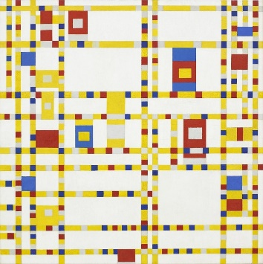
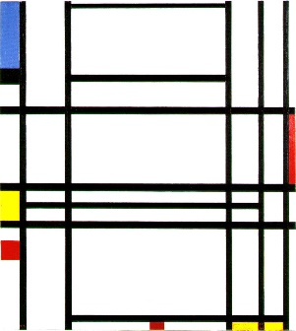

Art task for term to be completed in your own time:
Create you own piece of artwork that uses bold straight lines, different colours.
This could be in any type of medium such as:
- Pencils
- Felt tips
- pastels
- Painting
- Crayons
Remember presentation is important and please take your time to complete your masterpiece.
Any work can either be handed in to your class teacher, Elm class or emailed to elm@balliolschool.co.uk.
I would like all art work to be handed in by the beginning of June.

