Poppy Appeal
On Thursday and Friday this week, children will have the opportunity to bring in a donation to purchase items from the Royal British Legion.
The children should bring in money for anything they would like to make a donation for (suggested amounts below). The money should be in named envelopes with the name of the item that they would like.
The student leaders will visit the classes during the day for the children to be able to make their donations if they would like.
Suggested donations:
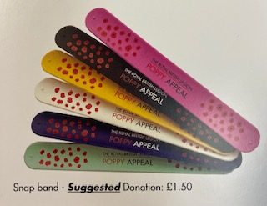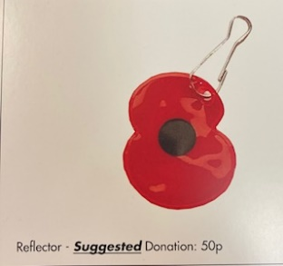
Snapband £1.50 Reflector 50p
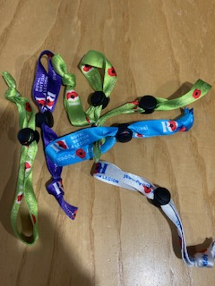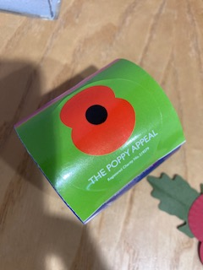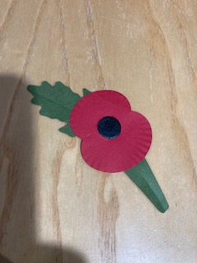
Wristband £1.00 Sticker 10p Paper Poppy 10p
We have only been sent a limited amount this year and so once they have gone then we will not be able to get any more.
Thank you for your support.

