Artist of the term is…
Lorna Simpson
Here are some examples of her work:
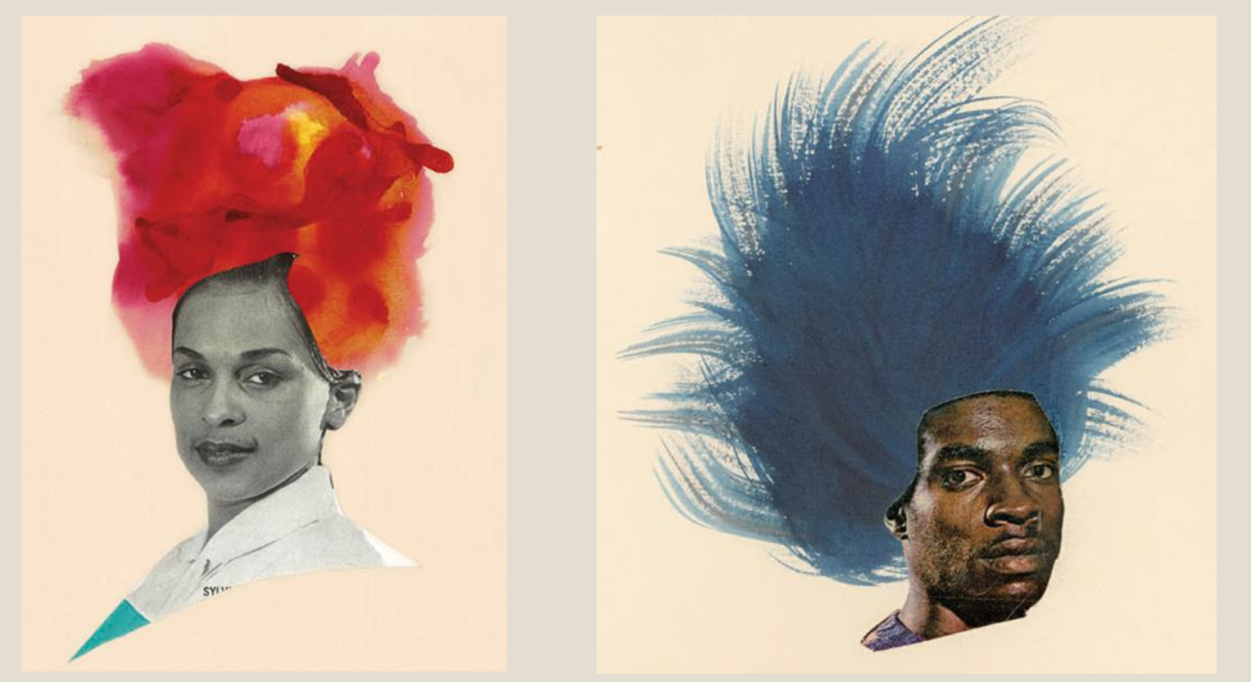

Art task for term to be completed in your own time:
Create you own piece of artwork that uses a picture from a person , this can be from a magazine or your own photos. Add in some crazy hair to the pictures.
This could be in any type of medium such as:
- Pencils
- Felt tips
- pastels
- Painting
- Crayons
Remember presentation is important and please take your time to complete your masterpiece.
Any work can either be handed in to your class teacher, Elm class or emailed to elm@balliolschool.co.uk.
I would like all art work to be handed in by the end of February.

