**Communication and Language** **Expressive Arts and Design**

Listening to stories – The Grouchy Ladybird, Superworm and Using various materials to create artwork such as The Hungry Caterpillar spoon bugs

Developing and learning new vocabulary Exploring animal music and bug songs

Participate in whole class and small group discussions

**Physical Development Understanding of the World**

Developing scissor control Looking the life cycles of minibeasts

Forming letters correctly Where do bugs live and what do they eat?

Holding pencils correctly Classification - How do I know if it is a bug or an insect.

Developing bat and ball skills Learning about positive relationships

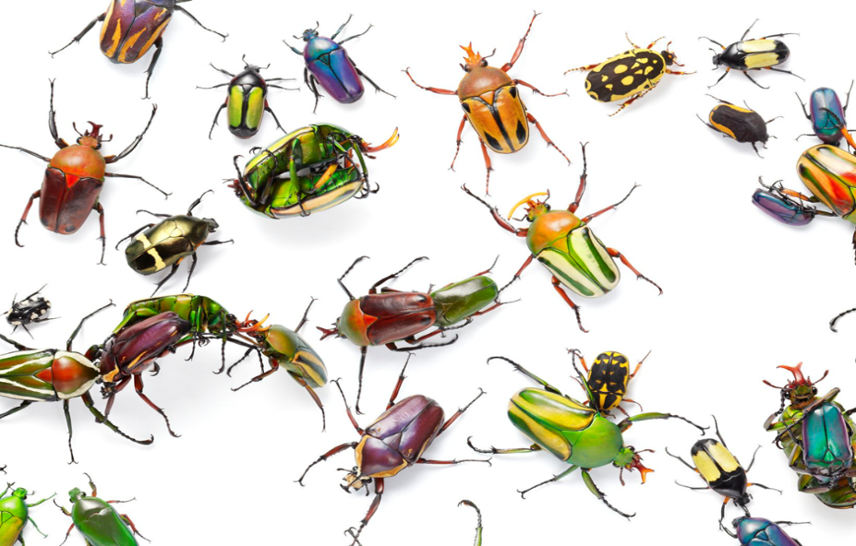

**Personal, Social and Emotional Development**

Creep, Crawl and Wriggle

Learning about positive relationships and staying friends

Solving problems and developing sharing and caring

skills.

Learning about different emotions and how to deal

with them.

**Literacy** **Maths**

Reading and sharing fiction and non-fiction books linked to topic. Counting patterns and building numbers beyond 10

Writing sentences and developing independent writing. Adding and taking away

Learning phase 2 and 3 sounds, blending and segmenting words. Spatial reasoning