

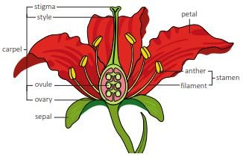
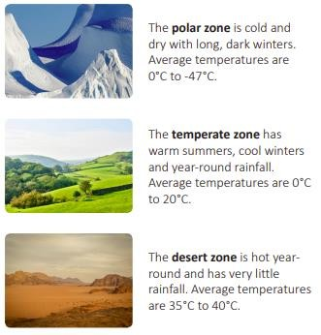
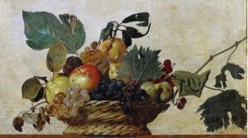
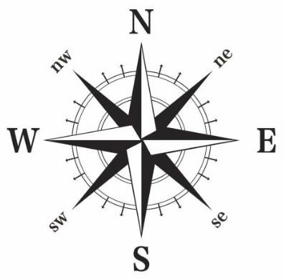

The children will learn about:
English:
- Narrative – English heritage. The Selfish Giant
- Poetry – Allotment poems
- Explanation – The Life Cycles of Frogs and Butterflies
- Class book – Sky Song (by Abi Elphinstone)

Science:
* Life Cycles

Geography:
- Land use and map skills
- Climate zones and food miles

Art:
- Still life sketching and
drawing techniques
- Watercolours

Other areas of learning:
Maths:
- Number - Place Value
- Number – Addition (+) and Subtraction (-)
RE:
* Religions in our local community
Music:
* ‘Livin’ on a prayer’ (Bon Jovi)
PSHE:
- Class rules
- Anti-bullying
- Being Me In My World.
French
*Francophones
DT
*Vegetable Casserole
PE:
* Quidditch and Yoga
Computing:
*We are Game Developers!

Investigate the geographical hypothesis, ‘The school field is the best location for an allotment.’ Work together to answer the hypothesis, considering the information given and using the score sheets to guide you. Each group will present and explain their conclusions.


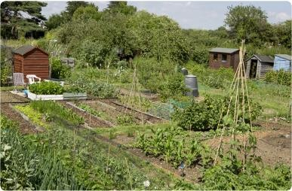

Year 5 – Autumn 1
Sow, Grow and Farm
We will create a planting area to plant some vegetables. We will assess the soil’s suitability, consider the climate and how that will impact growth and monitor the growth of our crops!

