**Welcome to Year 3!**

We are so excited to welcome your children into Year 3. We are looking forward to getting to know them all and learning lots whilst having lots of fun. This letter will outline a few things about this year, who to contact and your child’s login details to support learning at home.

**Contacting teachers**

Please email Miss James on [willow@balliolschool.co.uk](mailto:willow@balliolschool.co.uk) and Miss Muskett on [beech@balliolschool.co.uk](mailto:beech@balliolschool.co.uk) if you have any questions about anything. We also love to see photos of what your child gets up to at home!

**Website**

Please keep an eye on the class pages on the website for updates on what we have been up to and any extra information. You can find this by following the link <https://balliol-school.secure-primarysite.net/>, clicking on children – class pages – Willow/Beech.

**Reading**

Children will take home their reading book and reading record every day but this must be returned every morning to school as they will also read this in school. If you hear your child read at home, please sign in the reading record. If your child is on Accelerated Reader, has read their book twice and needs to do a quiz, please remind them to let an adult know in school and we will write their score in their reading record.

**Maths**

* TTRS is an online programme which supports children with learning their times tables. In Year 3, children are expected to know their 3s, 4s and 8 times tables by the end of the year to achieve their ‘Silver’ certificate. Children should regularly practise these at home and we will monitor the use of this in school.
  + <https://play.ttrockstars.com/ttrs/dashboard>
  + Please see your child’s login and password on the inside of their reading record.
* Optional MyMaths tasks will be available for the children to complete at home additionally to the homework set.
  + [www.mymaths.co.uk](http://www.mymaths.co.uk)
  + Please see your child’s login and password on the inside of their reading record.

**Snack**

Children may bring in a healthy snack, to eat during their break time. Please remember it must be healthy ☺

**Water**

Please provide your children with a named water bottle to bring into school daily.

Please turn over!

**PE**

Willow and Beech PE days are Tuesday and Thursday afternoons.

**Please ensure children come to school in their PE kits on these days. They will stay in these all day and will not be getting changed.**

**Topic**

Please see attached a knowledge organiser with lots of information on about our Autumn 1 topic, Gods and Mortals. Additional links and supporting activities can be found on the website.

**Spellings**

|  |  |  |  |  |  |  |  |  |  |  |
| --- | --- | --- | --- | --- | --- | --- | --- | --- | --- | --- |
| accident | bicycle | circle | eight | grammar | important | minute | popular | quarter | strange | woman |
| accidentally | breath | complete | eighth | group | interest | natural | position | question | strength | women |
| actual | build | consider | enough | guard | island | naughty | possess | recent | suppose |  |
| actually | busy | decide | exercise | guide | knowledge | notice | possession | regular | surprise |  |
| address | business | describe | experience | heard | learn | occasion | possible | reign | therefore |  |
| although | calendar | different | extreme | heart | length | often | potatoes | remember | though |  |
| answer | caught | difficult | famous | height | library | opposite | pressure | sentence | thought |  |
| appear | centre | disappear | favourite | history | material | ordinary | probably | separate | through |  |
| arrive | century | early | forward | imagine | medicine | peculiar | promise | special | various |  |
| believe | certain | earth | fruit | increase | mention | perhaps | purpose | straight | weight |  |

Children are expected to know how to spell the Year 1 and Year 2 common exception words as well as the Year 3 and 4 spellings listed below, by the end of the year 4. Please support your child with learning these at home whilst we provide regular opportunities for them at school to practise them.

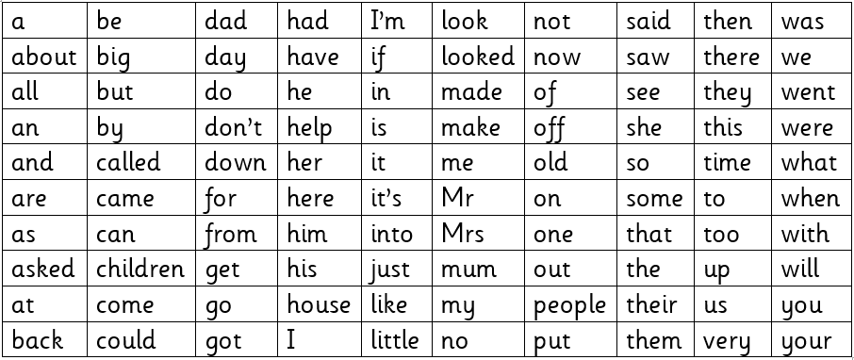

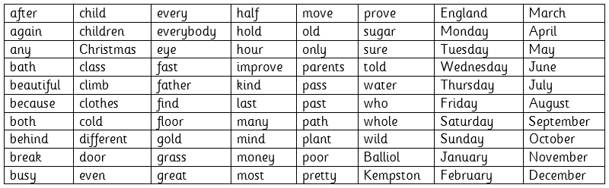

Any problems, please get in touch with us on the class emails. Thank you!

From Miss Muskett☺ and Miss James ☺