**Optional Year 5 Homework Task – DT**

**Friday 26th May 2023 Due Date: Friday 23rd June 2023**

For your task this half-term, we would like you to create a **marble run** todisplay in our classrooms**.** This will link with our new topic called **Scream Machine**, all about the science of fairground/theme park rides. You have **four weeks** to make it over the Summer half-term.

You could choose to create it with a variety materials including, cardboard, coloured card, toilet roll tubes, K-nex, Lego or various odds and ends like in junk modelling. We will test them in school by racing some marbles.

**You can make your marble run as simple or a complex as you like**. A name and theme for your marble run, as if it was a rollercoaster, would be fantastic. For example: ‘Losing Your Marbles’ with a crazy, outrageous paint job of bright colours.

On the bottom of this sheet are some examples of marble runs! You can create for a basic marble run created from one cereal box. A nicely decorated version of this would be lovely.

You may also wish to create a more complex marble run with loops, drops, turns and more. We leave it up to your imagination!

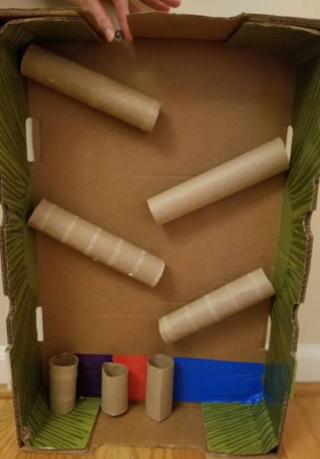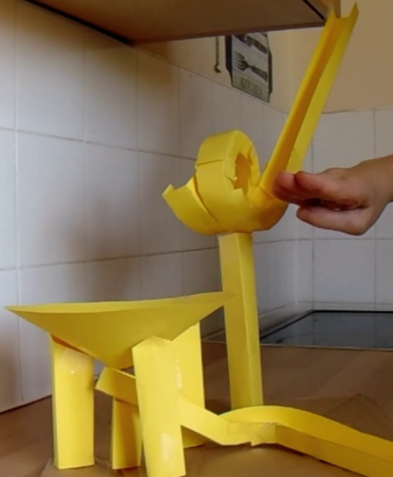

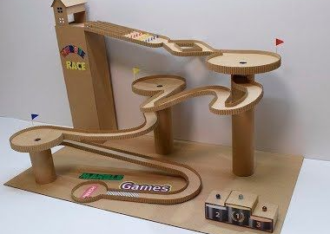

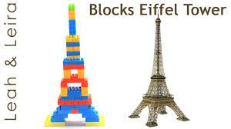

**Remember, you have four weeks to complete your marble run so we have expectations of a high quality product from you!**

**This is an optional task but we would really love to see as many products as we can! Finished products may be displayed around the school in our corridor and there will be a reward for those who put a lot of effort into their products!**