**Year 5 Project Homework Task – D.T./Science**

**Due Friday 17th November**

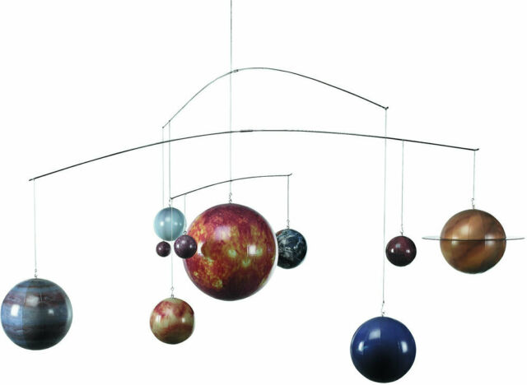For your first take-home topic task, create a **model of the Solar System**! The pictures below should help you with ideas, but here is a list of materials you could use to make your model:

* Polystyrene balls (different sizes!)
* Kebab skewers (wooden)
* Large piece of cardboard
* Paint
* Wire hangers
* Shoebox (for a diorama style model)
* String
* Clay/Plasticene/Saltdough

Ensure you put the planets in the **correct order** and do your best to ensure your model represents the **size** of the planets and their **proportion** in relation to one other. You should **label** each planet correctly, together with **at least two facts** about each planet.

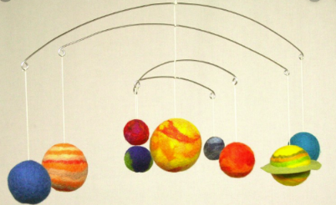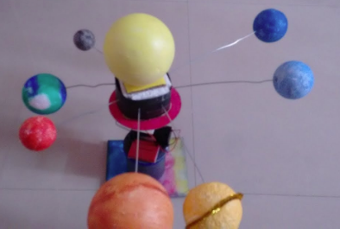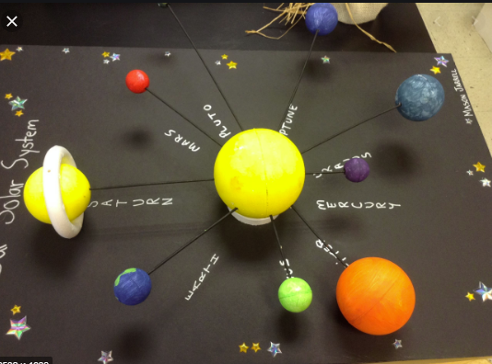

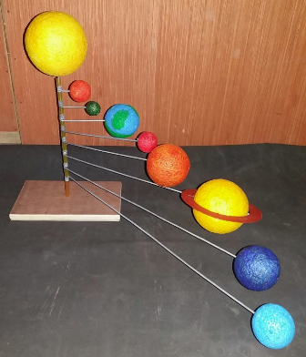

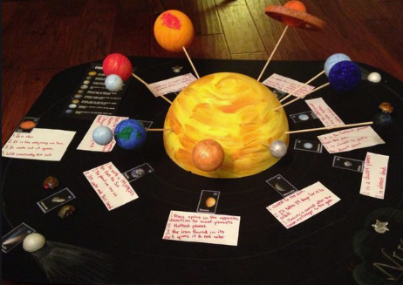

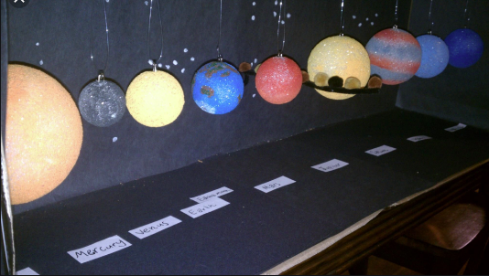

**Remember, you have 4 weeks to complete your model so we have expectations of a high quality solar system model from you!**

**This is an optional task but we would really love to see as many models as we can! Finished models may be displayed around the school and there will be a rewards for those who put a lot of effort into their models!**