grander  grandest  fresher  freshest  quicker  quickest  taller  tallest  slower  slowest | all  ball  call  walk  talk  always  small  wall  fall  altogether | dislike  disobey  discolour  discover  disappear  dishonest  disallow  disbelieve  disapprove  discontinue | submerge  subheading  submarine  subordinate  subway  superman  supervise  supersede  superpower  superhuman


Year 4 Spellings – week beginning 5th February
Dictionary definitions!    Use a dictionary to write the meanings for each word. | Silly sentences!    Use the words in a sentence that doesn’t make sense. | Rainbow Spellings!    Using bright felt tip pens or coloured pencils, write each word 5 times in different colours. | Typing or Texting!    Can you type the words onto a document? | Lego Letters!    Use Lego bricks to spell out your words. | 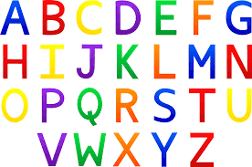  Alphabet!  Can you put the words in alphabetical order?
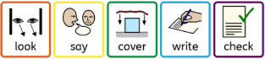  Look, say, cover, write, check!  Write the words out, checking that you are spelling them carefully. | Bingo!  Draw a grid like below and choose some of the spelling words. Ask a family member to do the same and then ask someone to read the words in a muddled order. The first one to cross them all off, wins! | 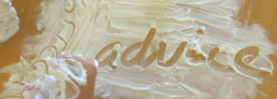  Sensory Spellings!  Can you paint the words?  Can you write the words in mud, sand or shaving foam?  Can you make the words out of playdough? | Word Searches!  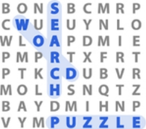  Use your words to make a word search. Make it more difficult by writing the words backwards or diagonal. | Sticky Spellings!    Use post-it notes for each letter of your spellings. Arrange the post-it notes so they spell the word correctly. |   Writing Outside!  Do you have chalks that you can use to write your words on the floor outside?
Full sentences!    Use the words in full sentences. Check that your sentences make sense and that they have the correct punctuation. |   Spelling Song!  Make up a spelling song. You could change the words to a well-known song or you may want to make up your own tune. |   Spelling Stories!  Using all of your words, can you make an exciting story up? | Highlighting!    See if you can find the spelling words in a newspaper. Use a highlighter or a felt tip pen to identify them. | Letters!  Do you have magnetic letters, scrabble pieces or cereal letters at home? Can you make your spellings words using these?   | Star Spellings!    Spell out your spelling word whilst star jumping for each letter.
Daily - 1) Remember which coloured group you are usually in and write your spelling words out neatly.
2) Choose 1 activity from the list below to practise your spellings for 5-10 minutes. Could you ask an adult to test you twice a week?

