**Optional Year 5 Homework Task – Art**

**Friday 31st March 2023 Due Date: Friday 28th April 2023**

For your task this Easter break, we would like you to create a Tudor Rose to decorate the walls outside the Y5 classrooms. This will link with our new topic called Off with Her Head, all about the Tudors. You have **four weeks** to make it over Easter break.

You could choose to create it in a variety of different ways including, cardboard, paint, coloured card, tissue paper or junk (for junk modelling). We would like them to be nice and big and bright! Think ‘bicycle wheel’ size!

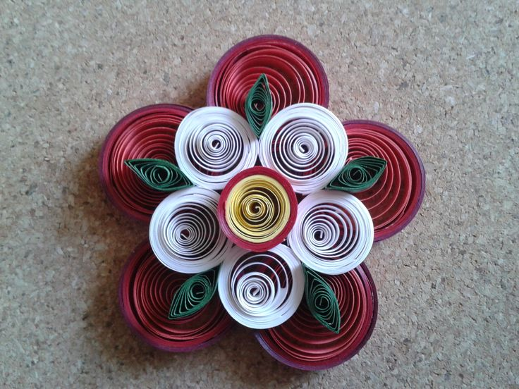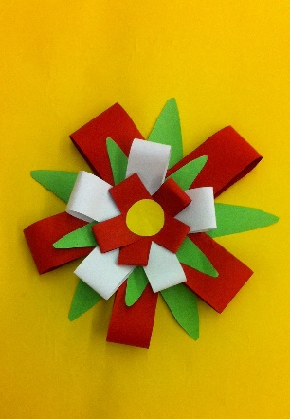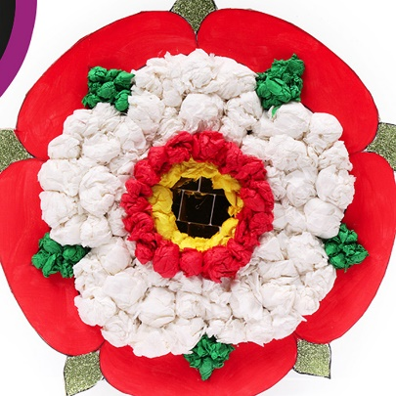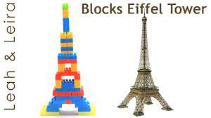

**Remember, you have four weeks to complete your Tudor rose so we have expectations of a high quality product from you!**

**This is an optional task but we would really love to see as many products as we can! Finished products may be displayed around the school in our corridor and there will be a reward for those who put a lot of effort into their products!**