Balliol Primary School Year 1 Keywords (inc Common Exception Words) Check (110)
a | big | do | has | if | love | old | saw | then | was
about | but | don’t | have | in | made | on | says | there | we
all | by | down | he | is | make | once | school | they | went
an | called | for | help | it | me | one | see | this | were
and | came | from | her | it’s | mum | our | she | time | what
are | can | friend | here | into | my | out | so | to | when
as | children | full | him | just | no | people | some | today | where
ask | come | get | his | like | not | pull | that | too | with
at | could | go | house | little | now | push | the | up | will
back | dad | got | I | look | of | put | their | us | you
be | day | had | I’m | looked | off | said | them | very | your

Year One children need to learn to read all 110 high frequency words and common exception words. They also need to learn to write and spell these from memory.
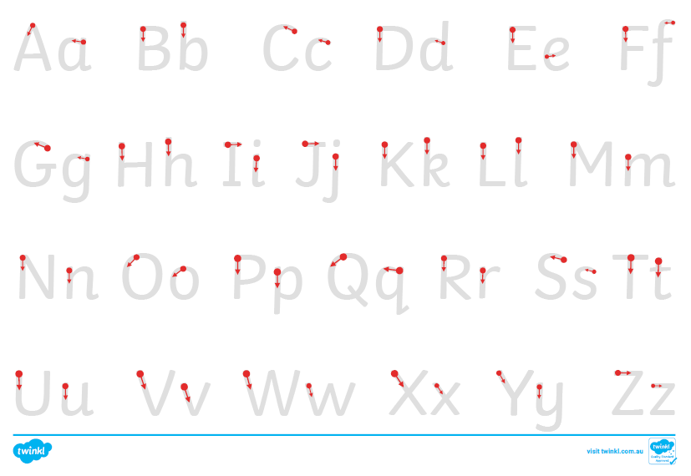
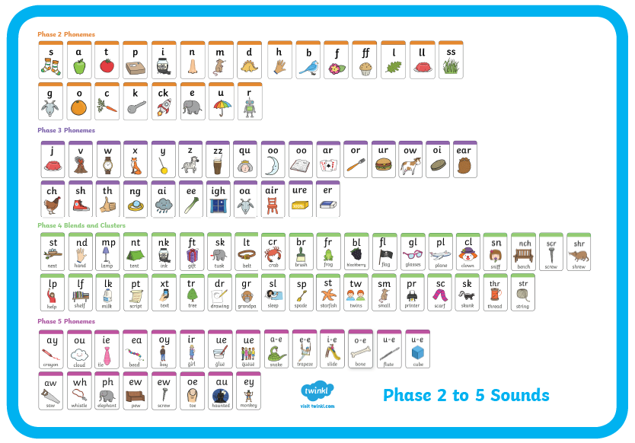
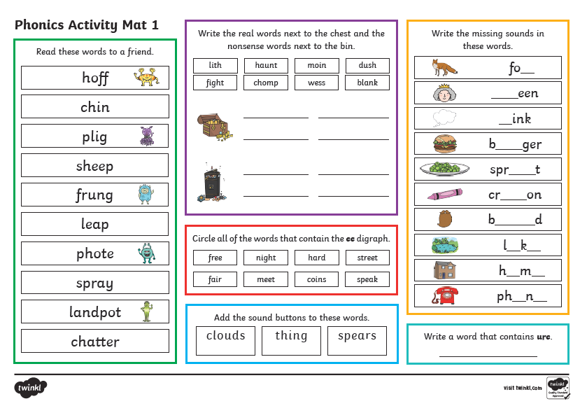
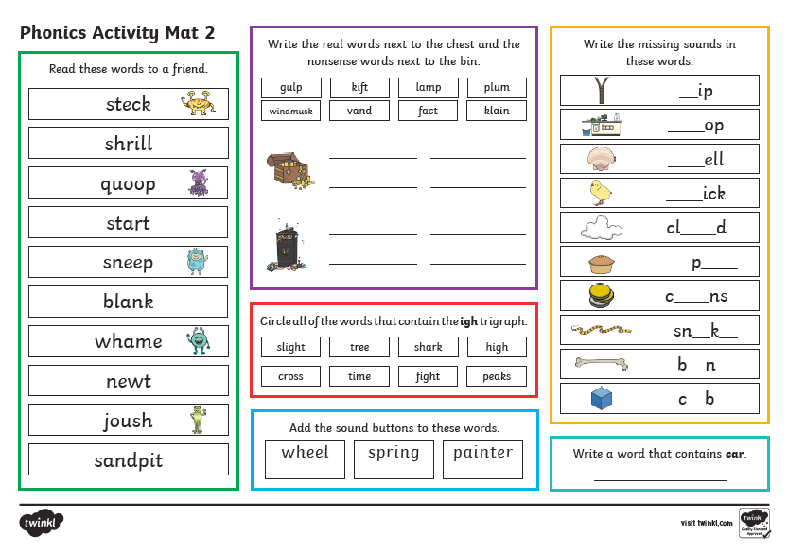
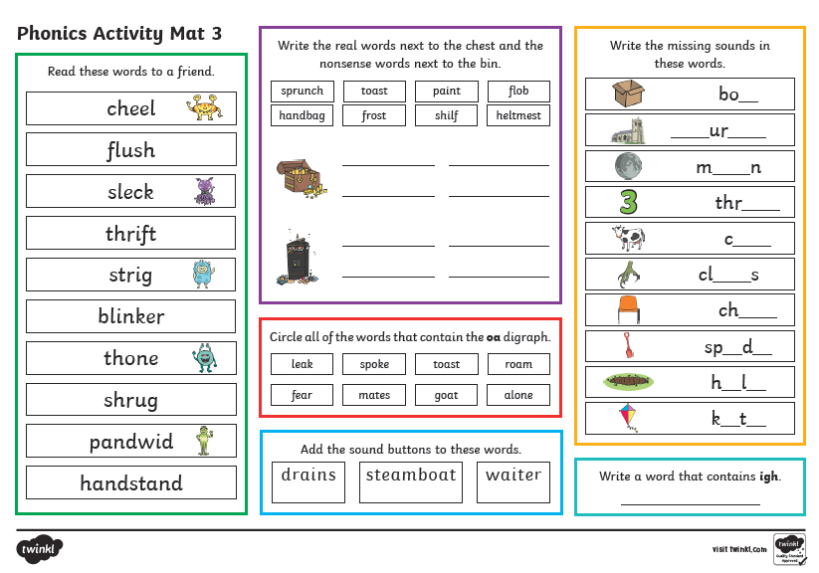
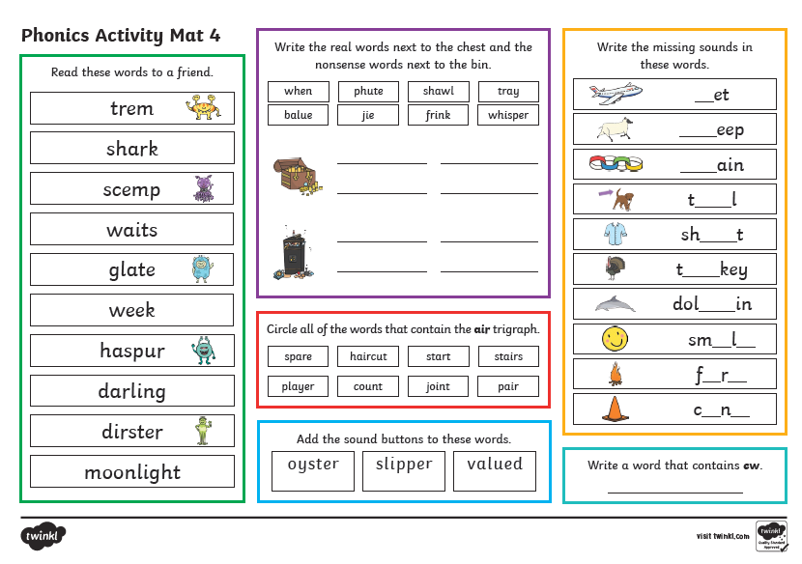
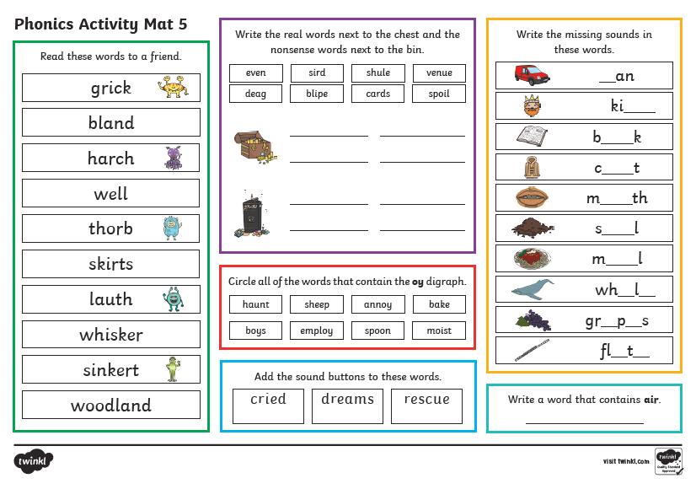
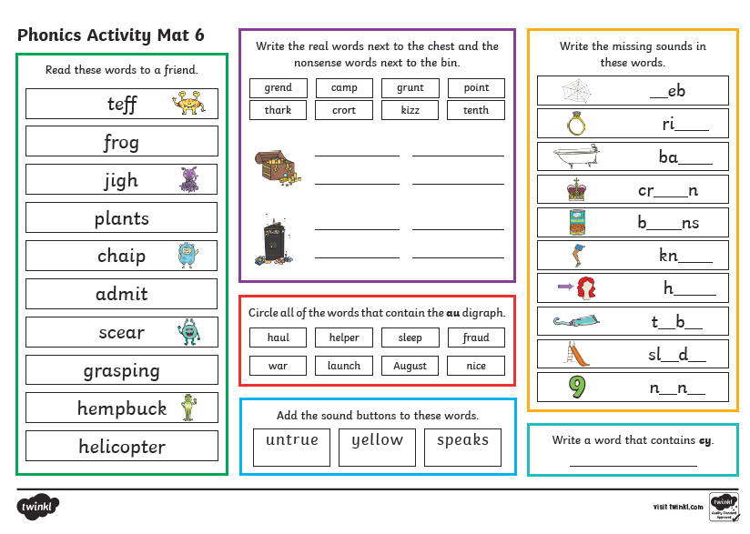

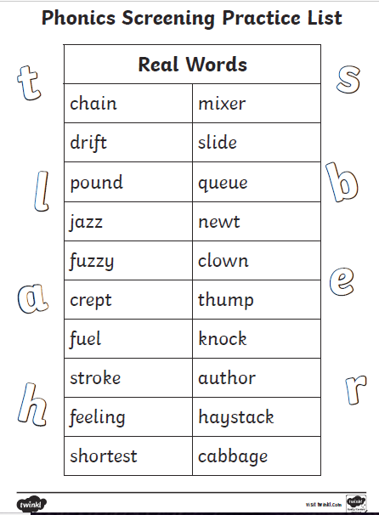

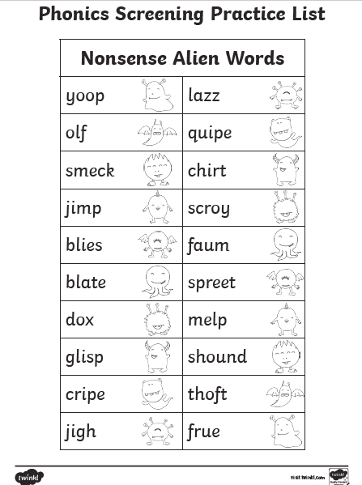
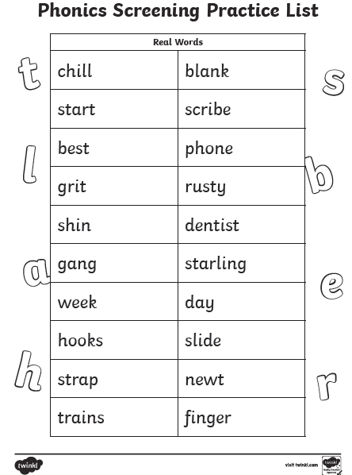

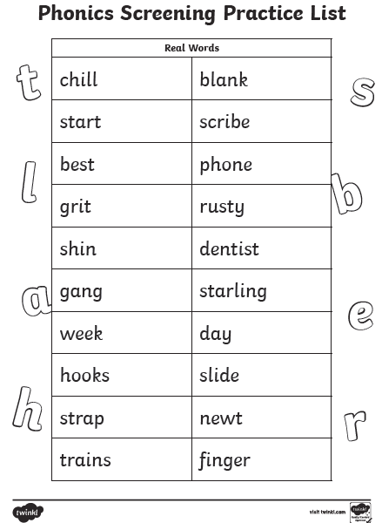

Things to work on in maths
- Numeral formations:
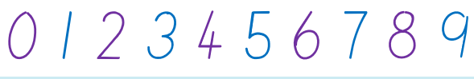
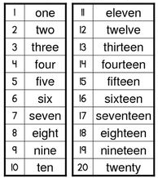
- Writing the numerals and spelling the words to 20. E.g. 1 one, 2 two, 3 three etc
- Recognising numbers to 100
- Counting forwards to beyond 100
- Counting backwards from at least 120
- Counting in 2s, 5s and 10s to beyond 100
- One more and one less than numbers to beyond 100
- Adding and subtracting using their fingers to count on or back e.g. 14 + 5 =. To work this out, the children put 14 in their heads and count on 5 more using their fingers 15, 16, 17, 18, 19 to get to 14 + 5 = 19
- Number bonds to 10 and then to 20 (e.g. 13+7, 3+17)
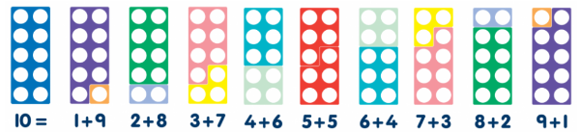
- Doubling numbers to 10 (e.g. double 5 is 10, double 3 is 6, double 9 is 18)
- Halving numbers (e.g. half of 14 is 7, half of is 3)
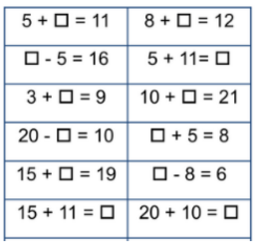
- Knowing the place value of numbers e.g. 28 has two tens and eight units, 114 has one hundred, one ten and four units
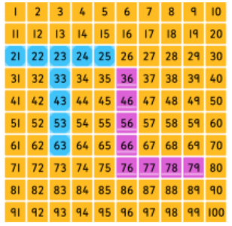
- Working out missing number problems

