Home learning websites and links
Please find below the links to the online programmes children already use in school and have access to that can support home learning.
- My maths (Y1-6) – Children will need their school login - https://www.mymaths.co.uk/ Choose a lesson, booster pack or game from the ‘Library’ section.
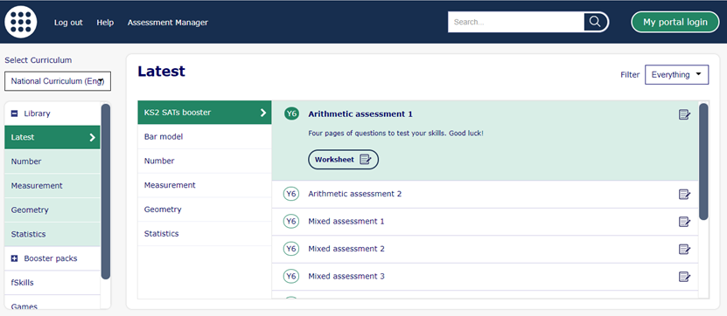
- TT Rockstars (Y2 upwards) – Children will need their school login details - https://ttrockstars.com/

- Pobble (whole school) - http://www.pobble365.com/
Use the activities, questions and story starters underneath the picture. Write an amazing story! There is a new picture EVERYDAY!

- BBC Bitesize (whole school) - https://www.bbc.co.uk/bitesize

- Espresso (whole school) - www.discoveryeducation.co.uk
- Click on “login” and select “Espresso” or “Coding”
- Enter your username: student4307
- Enter your password: espresso

- Read Theory (Year 6) – Children will need their school login in details
Many companies have also offered free subscriptions/trials for parents and schools who are affected by closures. Please find below a number of links to useful websites that are offering free access should we have to close.
- 10 minute shake up games - https://www.nhs.uk/10-minute-shake-up/shake-ups
- White Rose Maths (maths resources and video tutorials) - https://whiterosemaths.com/
- Twinkl (full curriculum resources and activities) – www.twinkl.co.uk/offer and enter code UKTWINKLHELPS
- Picture News - https://www.picture-news.co.uk
- Purple Mash – https://www.purplemash.com/login/
- Spelling Shed – https://www.spellingshed.com
- Maths Shed – https://www.mathshed.com
- Teach your monster to read - (Phonics and reading) EXCELLENT FOR EYFS AND Y1 - https://www.teachyourmonstertoread.com/
- Muddy Puddle Teacher- https://themuddypuddleteacher.co.uk/muddy-subscriptions/?utm_source=sendinblue&utm_campaign=FREE_Subscriptions_for_Parents__Schools_Affected_by_the_Coronavirus&utm_medium=email
- ExamWhizz (Ideal for Y2 and Y6) - https://www.examwizz.com/login - pupils will need login details. An email will be sent with log in details once we receive this information.

