made by Sophie Bartlett @_MissieBee
YEAR 6 MATHS KNOWLEDGE ORGANISER
Co-ordinates
Read co-ordinates along the x axis (horizontal) first, then the y axis (vertical). E.g. (3,-4) = go right 3, down 4.
Roman numerals
1 | I | 100 | C
5 | V | 500 | D
10 | X | 1000 | M
50 | L

2D shapes
Name | No. of sides
quadrilateral | 4
pentagon | 5
hexagon | 6
heptagon | 7
octagon | 8
nonagon | 9
decagon | 10
polygon = shape with straight sides
regular = all sides/angles the same
irregular = sides/angles not same
Types of triangle
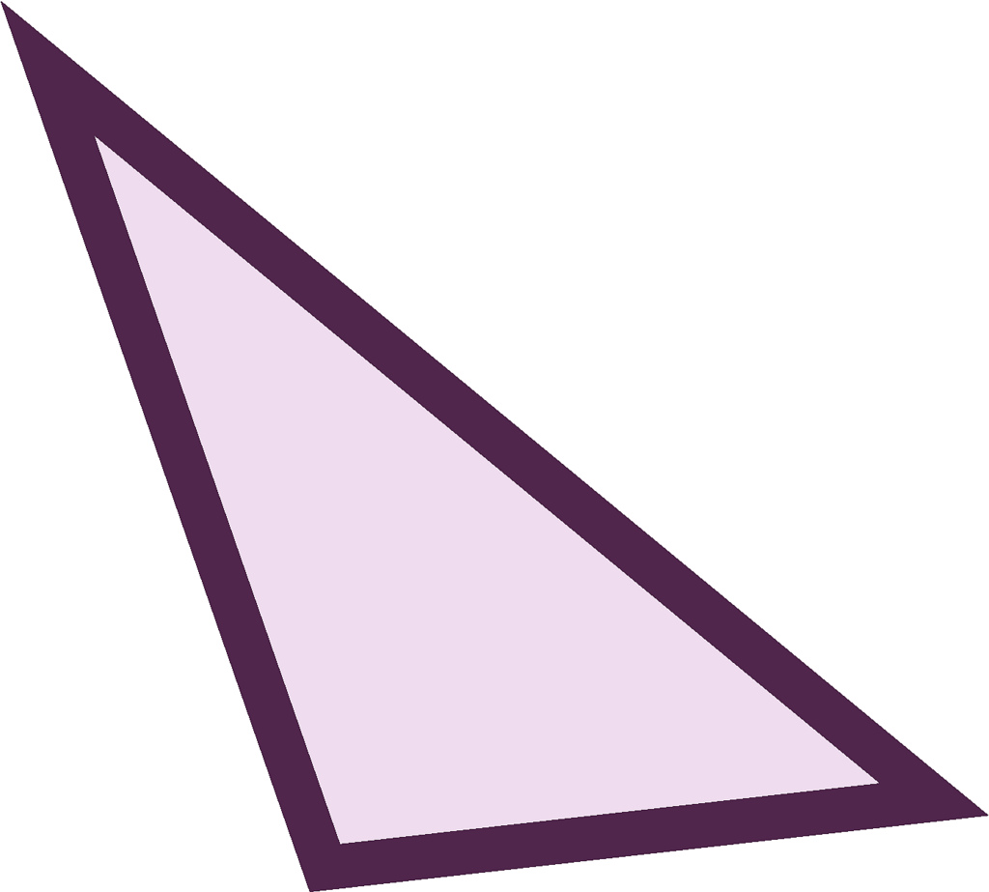 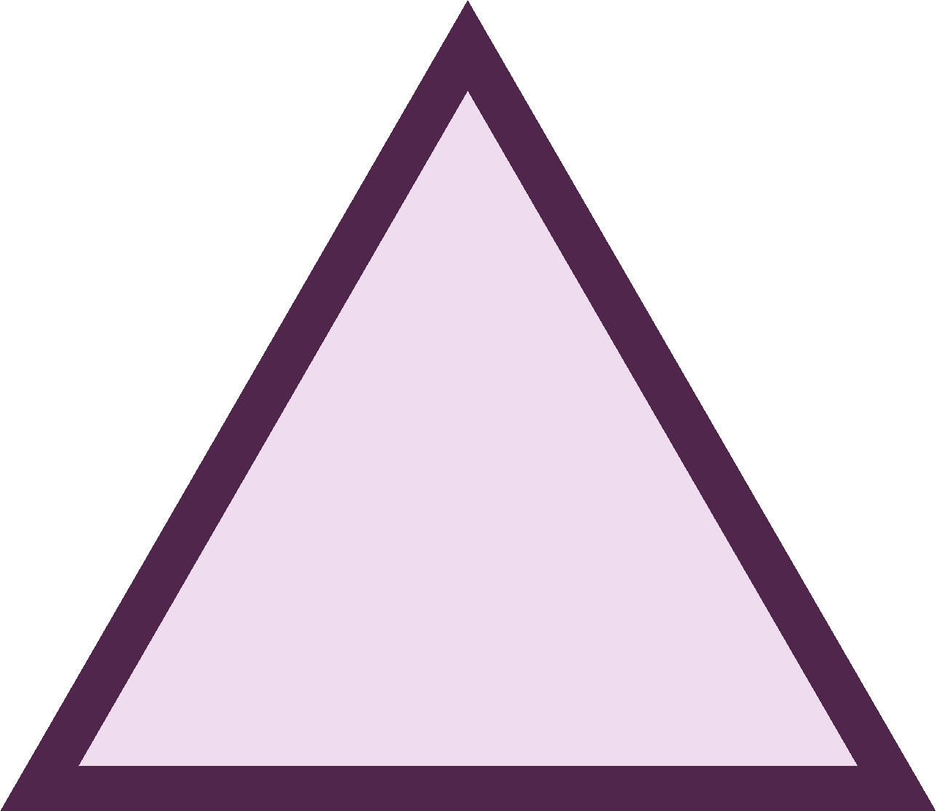 
scalene equilateral isosceles
Types of quadrilateral
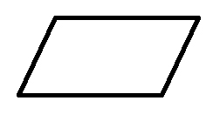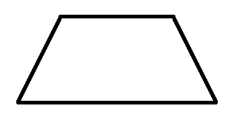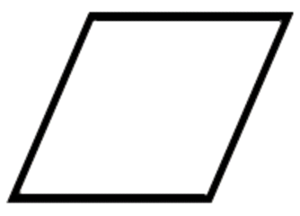
parallelogram trapezium rhombus
AREA
is the amount of space inside a 2D shape usually measured in cm² or m².
Area of a triangle
= (base x height) ÷ 2
Area of a parallelogram
= base x height
(Height = perpendicular height)

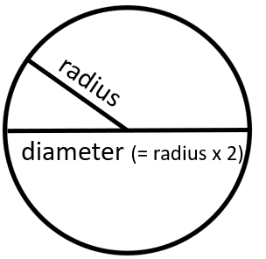
Shape vocabulary
perimeter = measure around the edge (circumference = perimeter of a circle)
horizontal line parallel lines
vertical line perpendicular lines
(at right angles)
The mean
The mean is a type of average. To find the mean, add up all the numbers and divide by how many there are. E.g. the mean of 4, 5, 3, 4 is 4. (Because 4 + 5 + 3 + 4 = 16, and 16 ÷ 4 = 4)
3D shapes | 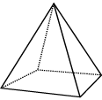  square-based pyramid | 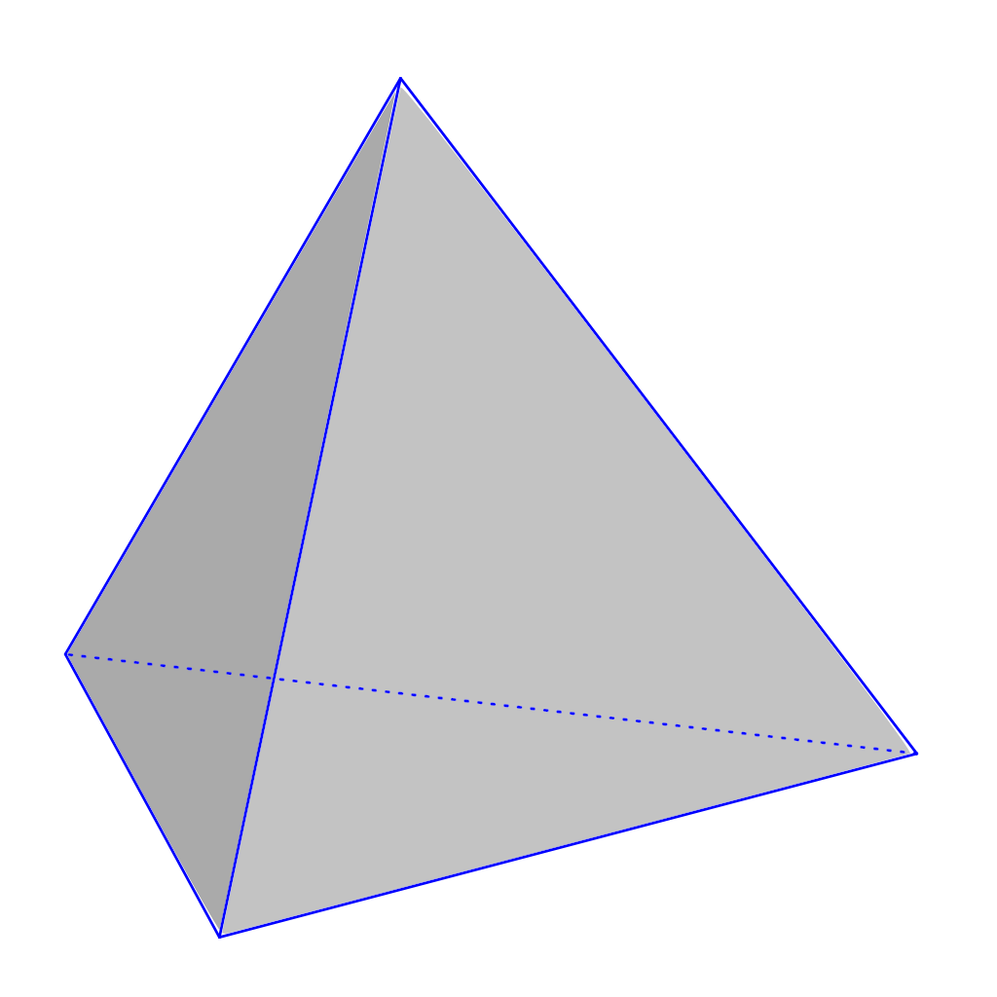  triangular-based pyramid | 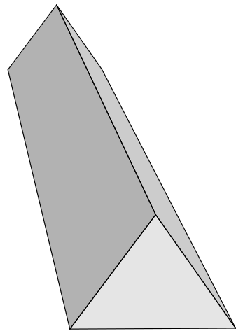  triangular prism
faces  (the flat sides) | 5 | 4 | 5
edges | 8 | 6 | 9
vertices  (the points where the edges meet) | 5 | 4 | 6
Volume = the amount of space a 3D shape takes up, usually measured in cm³ or m³
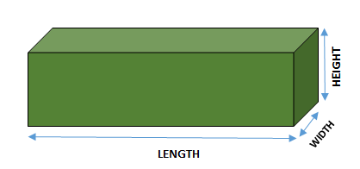
Volume of a cuboid = length x width x height
Angles
full turn | 360°
half turn | 180°
right angle | 90°
acute angle | < 90°
obtuse angle | > 90°
reflex angle | >180°
angles on a straight line | 180°
angles inside a triangle | 180°
angles inside a quadrilateral | 360°

Fractions, decimals & percentages
¹/₁₀₀ | 0.01 | 1% | ÷ 100
¹/₂₀ | 0.05 | 5% | ÷ 20
¹/₁₀ | 0.1 | 10% | ÷ 10
¹/₅ | 0.2 | 20% | ÷ 5
¼ | 0.25 | 25% | ÷ 4
½ | 0.5 | 50% | ÷ 2
¾ | 0.75 | 75% | ÷ 4, x3
1 | 1 | 100% | ÷ 1

Measurement conversions
Month | Days |  | 1 centimetre | 10mm
January | 31 |  | 1 metre | 100cm
February | 28 (29 in leap year) |  | 1 kilometre | 1,000 m
March | 31
April | 30 |  | 1 mile | 1.6 km
May | 31 |  | 1 kilometre | 0.625 (⁵/₈) mile
June | 30
July | 31 |  | 1 kilogram | 1,000 grams
August | 31
September | 30 |  | 1 litre | 1,000 millilitres
October | 31
November | 30
December | 31
1 year = 365 days (≈ 52 weeks)
Leap year = 366 days

Multiplication and division vocabulary
Term | Definition | Example
factor | a number that divides exactly into another number | factors of 12 =  1, 2, 3, 4, 6, 12
common factor | factors of two numbers that are the same | common factors of 8 and 12 = 1, 2, 4
prime number | a number with only 2 factors: 1 and itself | 2, 3, 5, 7, 11, 13, 17, 19…
composite number | a number with more than two factors | 12  (it has 6 factors)
prime factor | a factor that is prime | prime factors of 12 =  2, 3
multiple | a number in another number’s times table | multiples of 9 =  9, 18, 27, 36…
common multiple | multiples of two numbers that are the same | common multiples of 4 and 6 = 12, 24…
square numbers | the result when a number has been multiplied by itself | 25 (5² = 5x5)  49 (7² = 7x7)
cube numbers | the result when a number has been multiplied by itself 3 times | 8 (2³ = 2x2x2)  27 (3³ = 3x3x3)

