Microsoft Teams – A Guide for Parents and Carers

Thanks to Microsoft, all students in the UK are eligible for a full copy of Office 365 for free. The following guide is designed to get families started. Please email [office@balliolschool.co.uk](mailto:office@balliolschool.co.uk) or your child’s class teacher if you need any additional support.

Logging on:

All children at school should have been given their own personal login details in the following format: @balliolschool.co.uk

In order to login, they will need to go to https://login.microsoftonline.com/ or [www.office.com](http://www.office.com) where you will see the page displayed to the left. Here they can enter their username (your email address) and password (provided by us). Alternatively you can download the Office 365 and Teams apps on mobile devices and login.

Click on the Teams icon. You should now see all the Teams that their teachers have invited them to be part of.

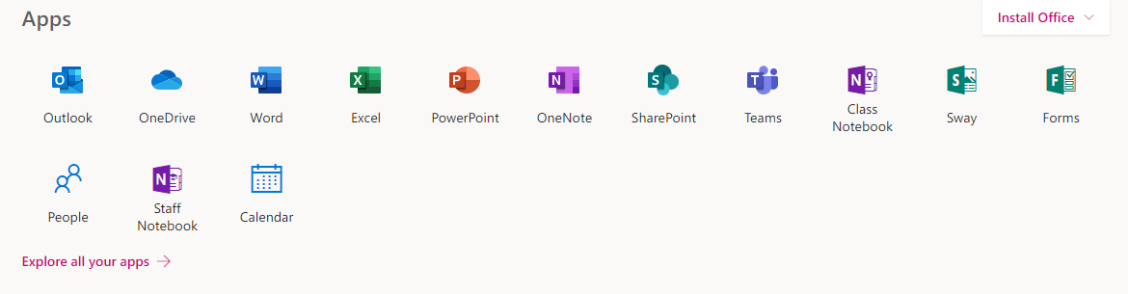

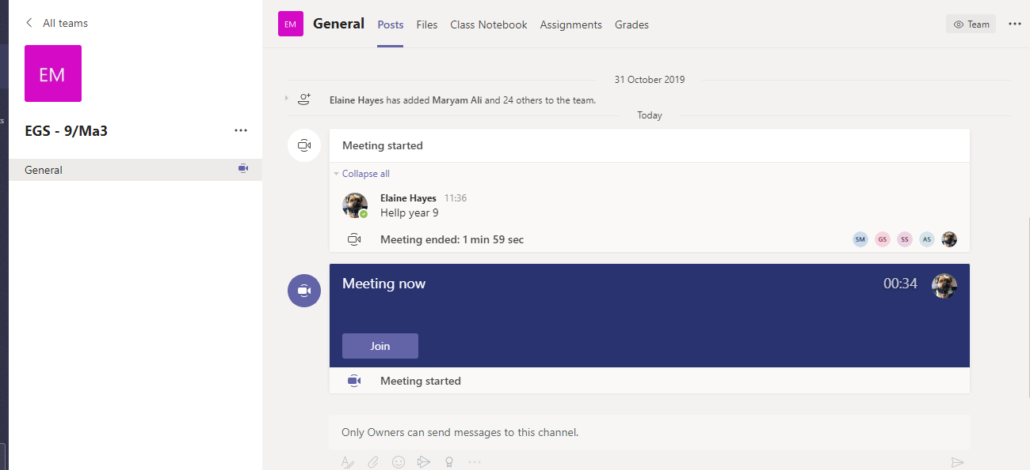Joining a Virtual Classroom video call:

If the teacher has started a virtual classroom, children will see a blue notification in their Team. The teacher should have notified you what time the lesson starts, and it can be joined at any time by clicking the join button as circled in red.

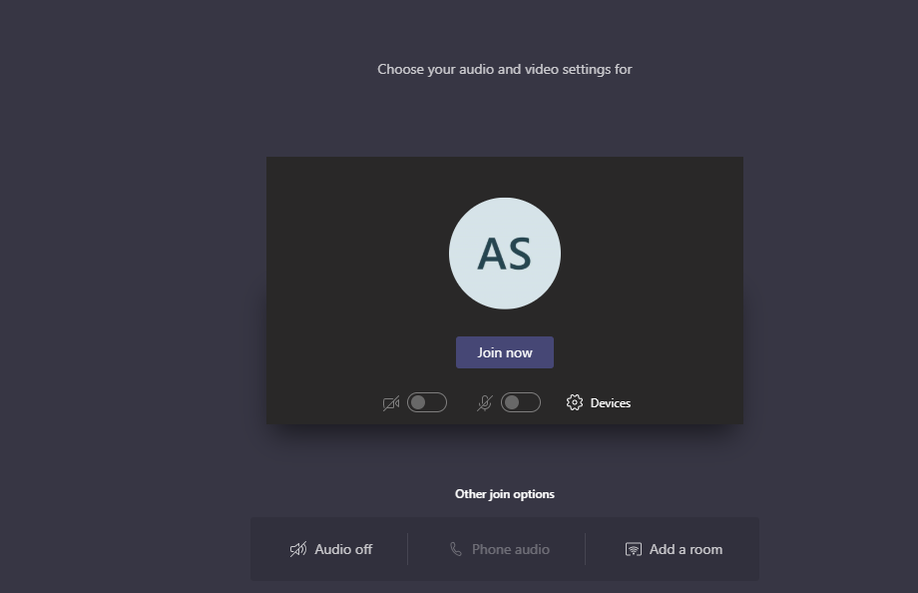

The red circle show where the camera functions and joining button are. Children may be asked to turn their microphone or camera on or off so make sure that they know where these buttons are.

Completing and uploading an assignment:

The teachers will set assignments for your children to complete. Children can access these in two different ways. Children can click the assignments button in the left-hand menu (red circle) to see all the different assignments set by their teacher, or they can click into their class and click on the assignments button circled in yellow.

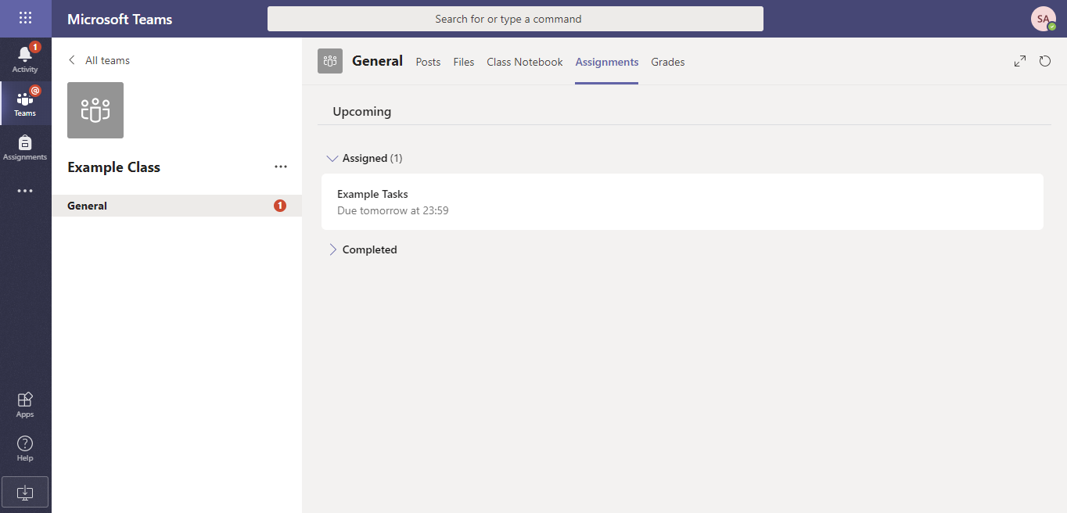

Click on the assignment to access the task.

To add their work, they will need to click on the add work button circled in red. They can add a document that they have already been working on, or create a new one that they can do their work on. The teacher should have given the children some instructions on how to submit their work.

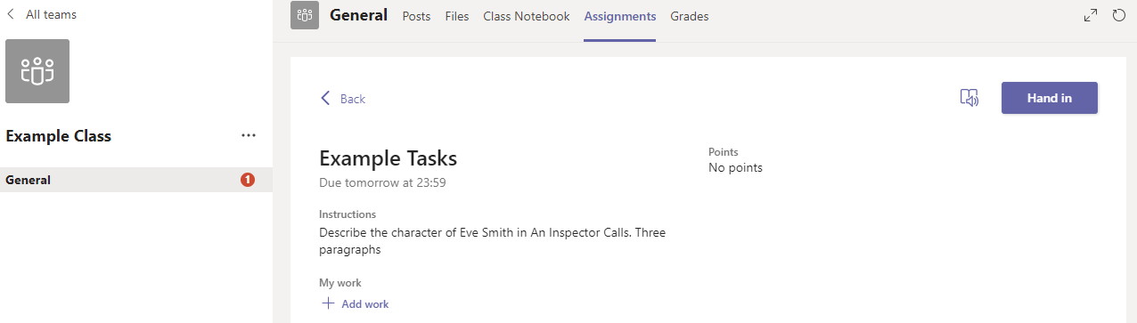

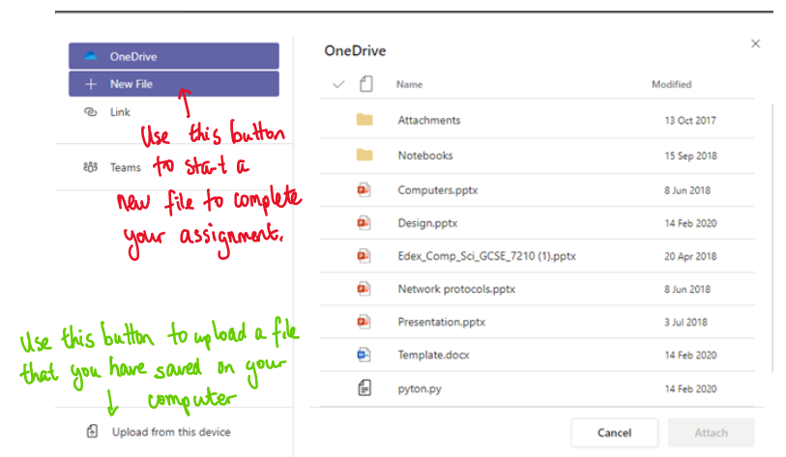

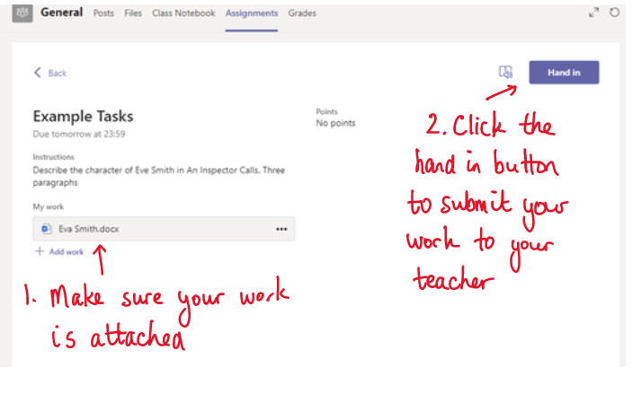

Make sure that your children have their work attached. Click the hand in button. The teacher can now look at their work and give feedback if required.

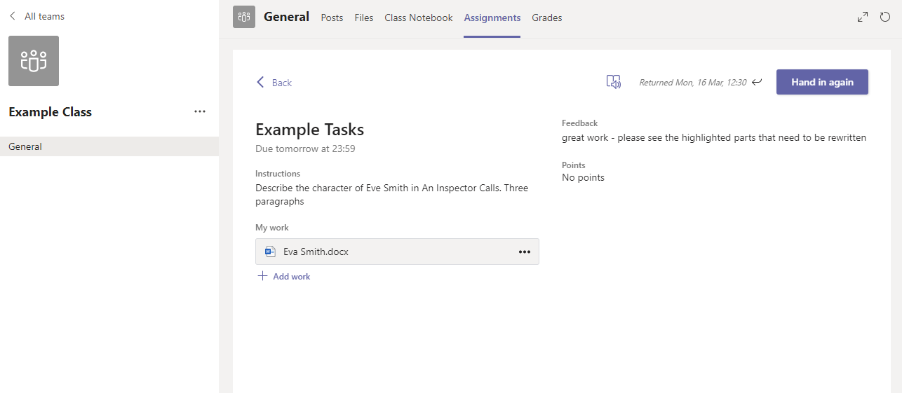

This piece of work has been looked at by this student’s teacher and been given some feedback circled in red. Children can click on the file to open it and act on the feedback given by their teacher, before handing it in again.

Files to help your child complete tasks will either be attached to the assignment itself or they can be find in the files section: 