How to Use Microsoft Teams

**Communication**

Each class has a general channel. Your teacher may post messages in here about work that you need to complete.

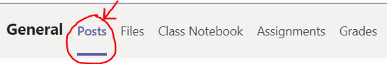

Teachers will be available between normal school hours.

If you need any help, ask your parent or carer to contact the school. Good luck!

**Work Set**

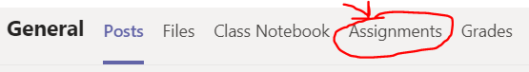

Your teacher will set you work each day that you cannot be at school. This will include English, Maths and Topic work. There might be assignments to complete or video calls to attend.

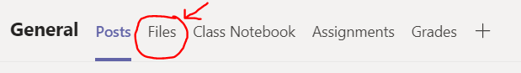

Resources for tasks such as PowerPoints will be saved in the Teams Files section.

**My Class**

Click on the Teams icon.



Click onto your class.

If you cannot see your class, please ask your parent or carer to contact the school for support.

**Logging in**

To login into Microsoft Teams, use your email address and password that you were given.

If you cannot remember it, ask your parent or carer to contact the school as soon as possible.

**Microsoft Teams**

Go to office.com to access Microsoft Teams via your web browser

OR

Download the Microsoft Teams App onto a Laptop, PC, tablet or mobile device.



